

0

1. Private Sub program1()
2. 'Data Declaration
3. Dim amount, rate, results As Double
4. amount = CDec(txtAmount.Text)
5. rate = CDec(txtRate.Text)
6. 'Caculate result by multiplying the amount with the exchange rate
7. results = amount * rate
8. 'Display the result
9. txtResult.Text = results
10. End Sub

**Perpus of program one:**

The perpous of the code is to do x y z in this code I have used a some of the following tools like text box so the user can enter 2 numbers then it is calculated and displayed on the screen

When I got the code I tried it and tested it and there was a problem so I tried it in a user form then the code worked

**Common words:**

**Input and output:** there are some inputs and outputs on the user form one has three on it and one has one on it where u press the button then the answer popups on the screen as an output box.

**Event handler:** the event handler is to do with the part of the code that is

Privet Sub Command click button _ 1 () and it can also be written as If Target.Cells.Count > 1 Then Exit Sub Like Line 1 on this is the event handler

**Constructs and techneeqs:**

Tools I have used in the program the numbers correspond to the numbers on the code.

1. Text Boxes
2. Output boxes
3. Buttons
4. User forms
5. 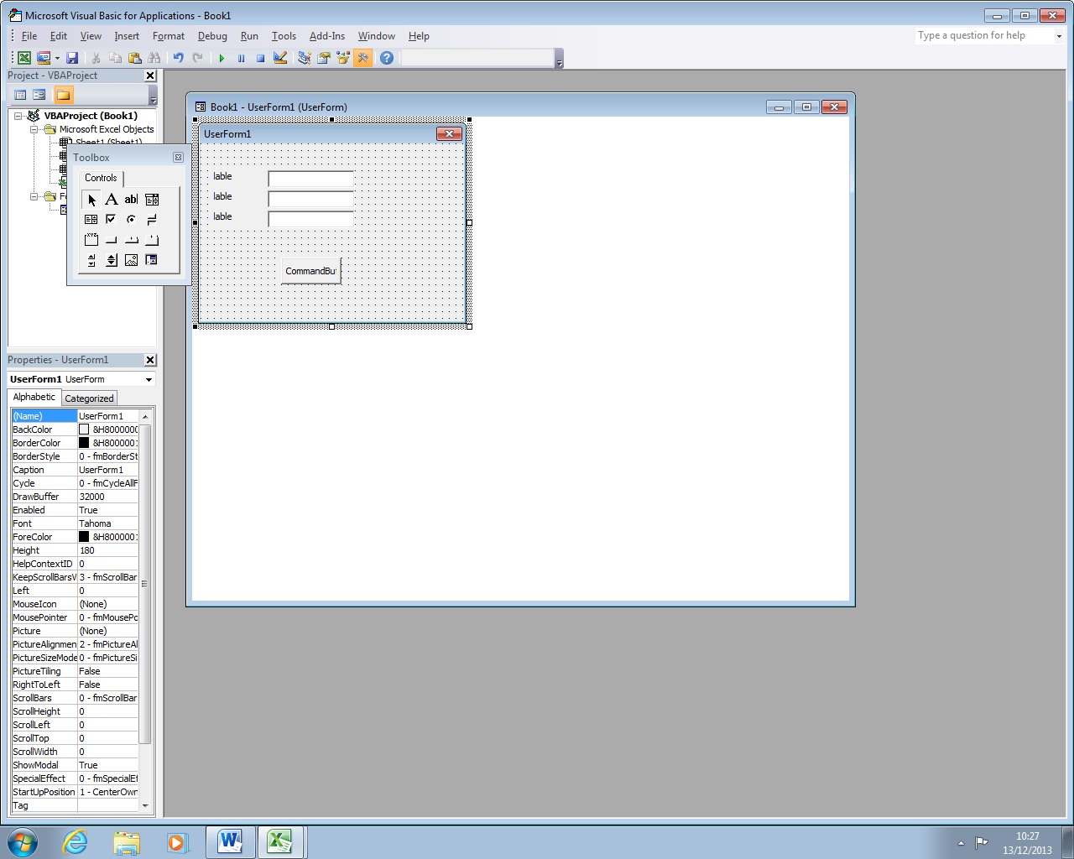
6. Private Sub CommandButton1_Click()
7. 'Data Declaration
8. Dim Sales Total As Integer
9. Sales Total = txtSalesTotal.Text
10. 'Amount entered into 'Sales Total' Text Box equal or exceeds 150,000 in the n'If Statement', Message Box to display 12,000
11. If Sales_Total > 150000 Then
12. MsgBox ("Bonus Achieved: 12,000")
13. 'Amount entered into 'Sales Total' Text Box ranges from 90,000 to 149,999 in the 'If statement', Message Box to display 8,000.
14. Elself Sales_Total >= 90000 And Sales_Total <= 149999 Then
15. MsgBox ("Bonus Achieved: 8,000")
16. 'Amount entered into "Sales Total' Text Box ranges from 50,000 to 89,999 in the 'If Statement'. Message box to display 5,000.
17. Elself Sales_Total >= 50000 And Sales_Total <= 89000 Then
18. MsgbBox ("Bonus achieved: 5,000")
19. 'Amount entered into 'Sales Total' Text Box less than 50,000 in the 'If Statement', Message Box to display 0.
20. Else: MsgBox ("Bouns Achieved: 0")
21. End If
22. End Sub

**The purpose of program 2:**

**Is to Caculate the sales total for the year**

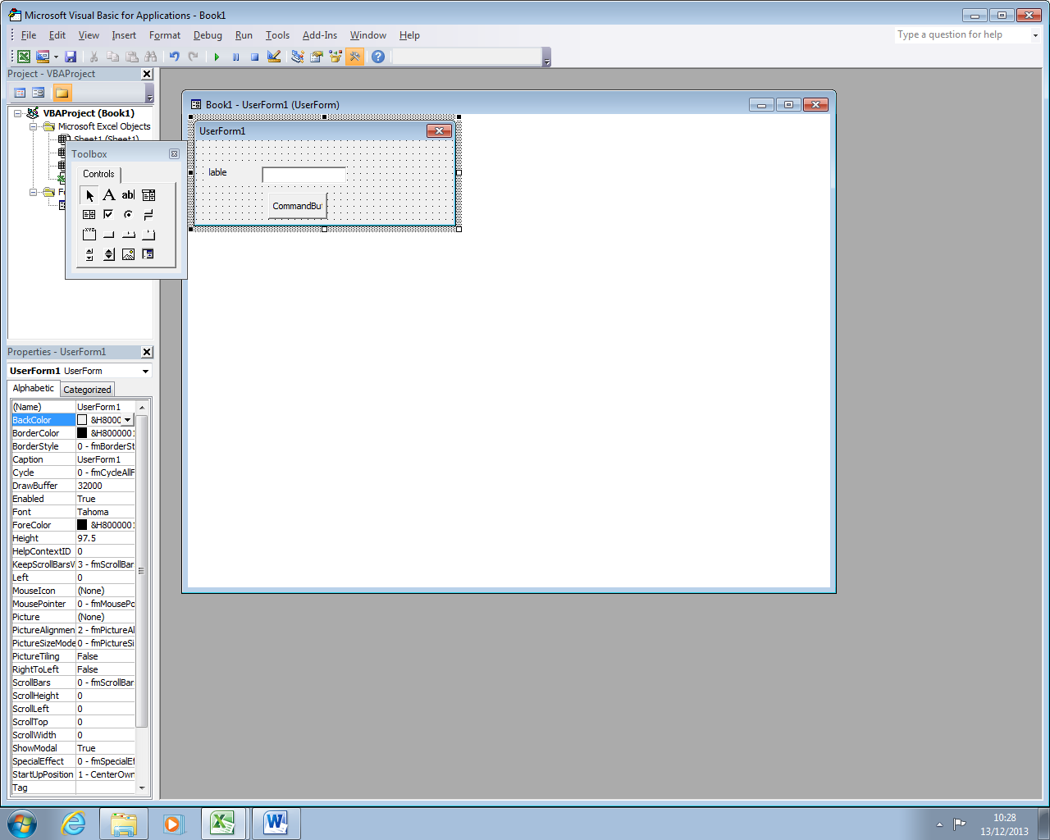

Private Sub CommandButton1_Click ()

1. 'Data Declaration
2. Dim Sales Total As Integer
3. Sales Total = txtSalesTotal.Text
4. 'Amount entered into 'Sales Total' Text Box equal or exceeds 150,000 in the n'If Statement', Message Box to display 12,000
5. If Sales_Total > 150000 Then
6. MsgBox ("Bonus Achieved: 12,000")
7. 'Amount entered into 'Sales Total' Text Box ranges from 90,000 to 149,999 in the 'If statement', Message Box to display 8,000.
8. Elself Sales_Total >= 90000 And Sales_Total <= 149999 Then
9. MsgBox ("Bonus Achieved: 8,000")
10. 'Amount entered into "Sales Total' Text Box ranges from 50,000 to 89,999 in the 'If Statement'. Message box to display 5,000.
11. Elself Sales_Total >= 50000 And Sales_Total <= 89000 Then
12. MsgbBox ("Bonus achieved: 5,000")
13. 'Amount entered into 'Sales Total' Text Box less than 50,000 in the 'If Statement', Message Box to display 0.
14. Else: MsgBox ("Bouns Achieved: 0")
15. End If
16. End Sub

**This code was broken but then I tried and fixed it and then it worked**

**Common words:**

**Inputs and outputs:**

There are only one input box and button and when u press the button it displays the answer on the screen

**Event handler:** the event handler is to do with the part of the code that is

Privet Sub Command click button _ 1 () and it can also be written as If Target.Cells.Count > 1 Then Exit Sub Like Line 1 on this is the event handler

**Constructs and techneeqs:**

Tools I have used in the program the numbers correspond to the numbers on the code.

1. Text Boxes
2. Output boxes
3. Buttons
4. User forms